MOHAMMAD SHAIK BASHA

192111459

4.CONNECTIVITY PROGRAM FOR STUDENT MARKSHEET

FORM:-

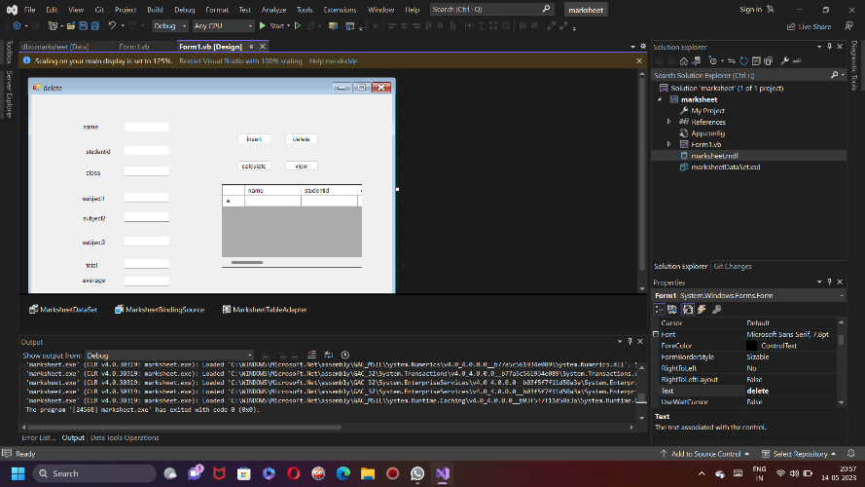

DATABASE:-

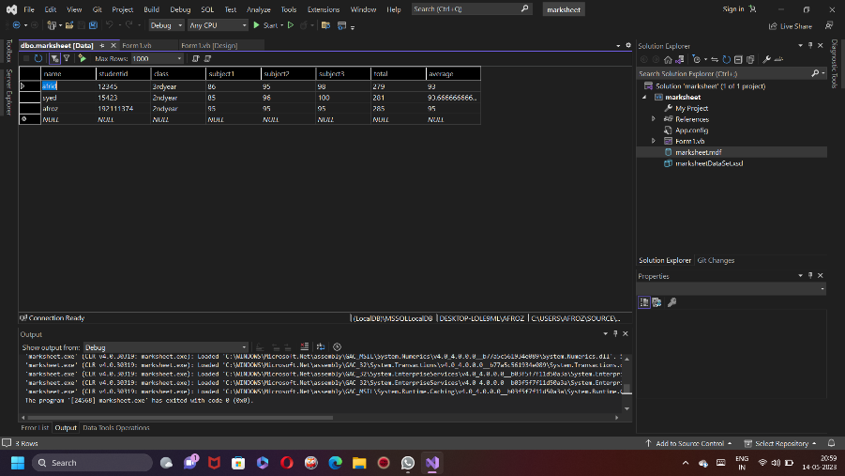

CODE:-

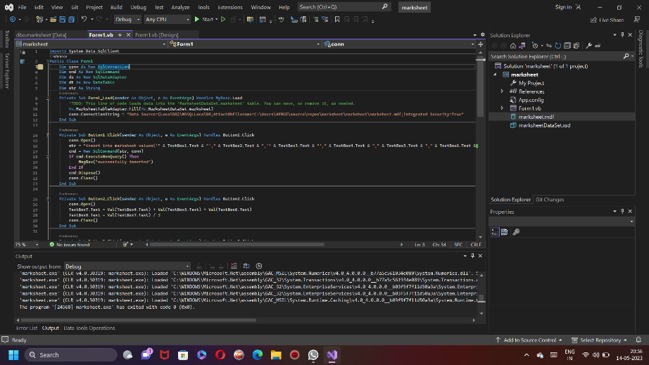

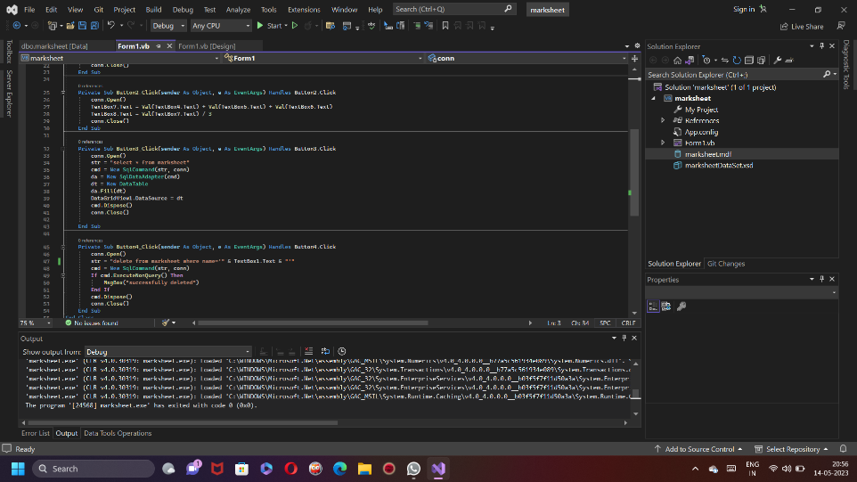

OUTPUT:-

